NHMS
Nursing Home Management System
SOFTWARE REQUIREMENTS SPECIFICATION
TEMPLATE
Version: Template v1.0
Date: 15/07/2026
Applies to: Auth & Shared · AD – System Administration · M1 – Intake & EHR · M2 – Care Planning · M7 – Incident Management (45 screens)
Status: Shared template — duplicate for each specific screen/function

Table of Contents

0. How to Use This Template
This template standardizes how an NHMS screen/function is specified into 4 blocks: Function Information, Screen Content, Actions, and Error Messages. When drafting the spec for a new screen, copy the whole block in section 3.1.1 (marked WORKED EXAMPLE) into the matching position within your group, then replace the content.
Quality checklist before handoff:
- The user must be a specific actor by role (Nurse RN/LPN, CNA, DON, Admission Staff, System Admin…) — do not use a generic "User".
- The Function Information table must have all 7 rows filled in; if a row does not apply, write "N/A" with a short reason instead of leaving it blank.
- The Screen Content table must list the screen's actual fields (name, type, data constraint, required or not) — do not use generic placeholders such as "Field 1", "Field 2".
- The Actions table must clearly separate Main Flow and Alternate Flow, numbering steps alternately between the Actor and System columns in the exact order of execution.
- The Error Message table must cover: missing required fields, invalid format/value, duplicate data; for sensitive operations (delete, approve, lock/unlock a record…) it must also include a confirmation message or an audit log entry.
- Screen ID must follow the convention [Module]-[Role]-[Sequence] (e.g. M1-US-03) or AD-[Sequence] for Admin screens, kept in sync with the corresponding wireframe and User Story.
- Do not keep the sample data from the worked example (section 3.1.1) when applying it to another screen — every screen has its own business rules.

1. Overview

1.1. Purpose
This document specifies the functional requirements and UI conventions for NHMS — an integrated EHR/EMR and ERP platform for Long-Term Care facilities, managing the entire resident care lifecycle from intake to discharge. This template is the standard framework used when drafting the spec for any new module or screen.

1.2. Scope
This template applies to all 45 screens currently in NHMS (see the full list in section 3.0), grouped into 5 sets:
- Auth & Shared: login, account activation, two-factor verification, role-based dashboard.
- AD — System Administration: accounts, permissions, system configuration (LOC rate, staffing ratio, SLA…).
- M1 — Intake & EHR: intake, clinical assessment, LOC classification.
- M2 — Care Planning: care plan creation/approval, daily care tasks, reassessment.
- M7 — Incident Management: reporting, handling, locking/unlocking incident records.
Modules outside the current scope (eMAR, detailed Billing, third-party integrations) will reuse this template once they are brought into scope in a later phase.

1.3. Terms & Abbreviations
LOC | Level of Care — the resident's care intensity, determined through clinical assessment; used as the basis for billing and staffing allocation.
DON | Director of Nursing — approves care plans and makes acuity/serious-incident decisions.
CNA | Certified Nursing Assistant — performs daily care tasks (vitals, hygiene, feeding).
RN/LPN | Registered Nurse / Licensed Practical Nurse — performs clinical assessments and builds care plans.
IDT | Interdisciplinary Team — the cross-discipline group that multi-signs off on a care plan.
eMAR | electronic Medication Administration Record — currently out of scope for this template.
POA/DNR | Power of Attorney / Do Not Resuscitate — legal and medical directives attached to a resident's record.
2FA | Two-Factor Authentication — mandatory phone-based second factor at login.
SLA | Service Level Agreement — the committed turnaround time (e.g. incident resolution deadline).
RBAC | Role-Based Access Control — permissions assigned by role.

2. Use Case Diagram

2.1. Actors
System Administrator | Manages accounts, roles/permissions, and system configuration (module AD).
Admission Staff | Creates resident records and coordinates the intake process (module M1).
Nurse (RN/LPN) | Performs clinical assessments, builds care plans, and handles incidents (modules M1, M2, M7).
CNA (Caregiver) | Performs daily care tasks, logs vitals, and reports incidents (modules M2, M7).
DON (Director of Nursing) | Approves care plans, decides acuity, and resolves serious incidents (modules M2, M7).
Family/Guardian (external) | Views health updates, menus, and invoices — outside the current core MVP scope.

2.2. Overview Use Case Diagram
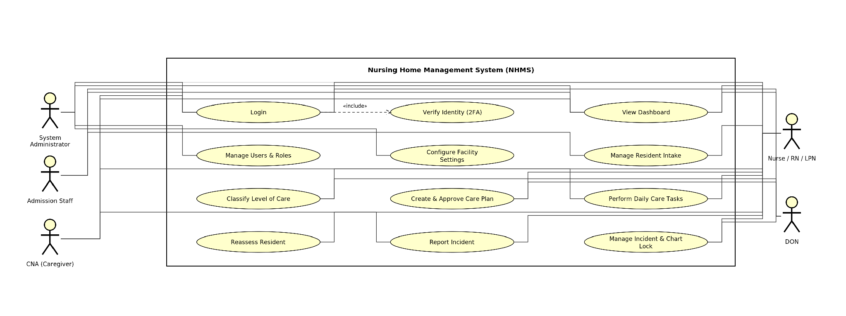
Figure 2.2 — NHMS Overview Use Case Diagram (Astah style; System Administrator, Admission Staff, Nurse/RN/LPN, CNA, DON)

3. Functionality
Each screen/function is specified using 4 standard blocks: (a) Function Information, (b) Screen Content, (c) Actions, (d) Error Messages. Section 3.0 lists all 45 screens currently in NHMS (post-CR-01 baseline); the groups are presented in the order Auth & Shared → AD → M1 → M2 → M7, with screens numbered sequentially by Screen ID within each group.

3.0. Screen Inventory
The table below summarizes all 45 NHMS screens by SC Code (the lookup code for wireframes/US+AC), Screen ID (following the [Module]-[Role]-[Seq] convention), screen name, and original owner. This is the current baseline — when a CR introduces a new screen, add it directly to the matching group and renumber.
No. | SC Code | Screen ID | Screen Name | Owner
AUTH & SHARED — Login / Activation / Verification / Dashboard
1 | SC_001 | AD-00 | Login | Kieu Quang Van
2 | SC_002 | AD-00b | Account activation | Kieu Quang Van
3 | SC_003 | AD-15 | 2-step verification | Kieu Quang Van
4 | SC_014 | SH-US-01 | Dashboard — Nurse | Phan Thanh Loc
5 | SC_015 | SH-US-01 | Dashboard — DON | Phan Thanh Loc
6 | SC_016 | SH-US-01 | Dashboard — CNA | Phan Thanh Loc
AD — System Administration
7 | SC_004 | AD-01 | User list | Kieu Quang Van
8 | SC_005 | AD-02 | Create/edit user | Kieu Quang Van
9 | SC_006 | AD-03 | Role & permission matrix | Kieu Quang Van
10 | SC_007 | AD-05 | Facility settings | Kieu Quang Van
11 | SC_046 | AD-05 | Facility settings — tab “Holidays” | Kieu Quang Van
12 | SC_047 | AD-05 | Add/Edit State Holiday Popup | Kieu Quang Van
13 | SC_008 | AD-06 | LOC rate table | Phan Thanh Loc
14 | SC_009 | AD-07 | Staffing ratio | Phan Thanh Loc
15 | SC_010 | AD-08 | Incident severity levels | Phan Thanh Loc
16 | SC_011 | AD-09 | SLA configuration | Phan Thanh Loc
17 | SC_012 | AD-10 | Demo data seeder | Phan Thanh Loc
18 | SC_013 | AD-16 | Equipment & supply inventory | Phan Thanh Loc
M1 — Intake & EHR
19 | SC_017 | M1-US-01 | Resident list | Huynh Ngoc Thien
20 | SC_018 | M1-US-02 | Resident profile detail | Huynh Ngoc Thien
21 | SC_019 | M1-US-03 | Create/edit resident | Huynh Ngoc Thien
22 | SC_020 | M1-US-04 | Pre-admission screening | Huynh Ngoc Thien
23 | SC_021 | M1-US-05 | Admission form | Huynh Ngoc Thien
24 | SC_022 | M1-US-06 | Initial assessment | Huynh Ngoc Thien
25 | SC_023 | M1-US-07 | Assessment history | Huynh Ngoc Thien
26 | SC_024 | M1-US-08 | LOC classification | Huynh Ngoc Thien
27 | SC_025 | M1-US-09 | LOC history | Huynh Ngoc Thien
M2 — Care Planning
28 | SC_026 | M2-US-01 | Care plan list | To Duy Bac
29 | SC_027 | M2-US-02 | Care plan create | To Duy Bac
30 | SC_028 | M2-US-02b | LOC gate | Kieu Quang Van
31 | SC_045 | M2-US-02c | Add Custom Care Area popup | Kieu Quang Van
32 | SC_029 | M2-US-03 | Care plan detail | To Duy Bac
33 | SC_030 | M2-US-04 | DON review | To Duy Bac
34 | SC_031 | M2-US-04b | E-signature popup | To Duy Bac
35 | SC_032 | M2-US-05 | Daily task list | To Duy Bac
36 | SC_033 | M2-US-06 | Bedside vitals | To Duy Bac
37 | SC_034 | M2-US-07 | Reassessment | To Duy Bac
38 | SC_035 | M2-US-09 | Cost/billing panel | Nguyen Thi Phuong Thao
39 | SC_036 | M2-US-10 | IDT acknowledgment | Nguyen Thi Phuong Thao
M7 — Incident Management
40 | SC_037 | M7-US-01 | Report incident | Nguyen Thi Phuong Thao
41 | SC_038 | M7-US-02 | Chart lock confirmation | Nguyen Thi Phuong Thao
42 | SC_039 | M7-US-03 | Incident detail | Nguyen Thi Phuong Thao
43 | SC_040 | M7-US-04 | Incident list | Nguyen Thi Phuong Thao
44 | SC_041 | M7-US-06 | Submit external report | Nguyen Thi Phuong Thao
45 | SC_042 | M7-US-07 | Chart unlock | Nguyen Thi Phuong Thao
46 | SC_043 | M7-US-03b | Incident detail (unlocked) | Nguyen Thi Phuong Thao
47 | SC_044 | M7-US-03 | Incident detail (Nurse/CNA view) | Nguyen Thi Phuong Thao

3.1. AUTH & SHARED — Login / Activation / Verification / Dashboard

3.1.1. [WORKED EXAMPLE] Login (Screen ID: AD-00)
a) Function Information
Function Name | Login
High-Level Requirement | Allows a user to log in to NHMS using the email or phone number that a System Admin has provisioned for their account.
User | All internal actors with an existing account: System Admin, Admission Staff, Nurse (RN/LPN), CNA, DON.
Description | Authenticates the email/phone and password. If the account has mandatory 2FA enabled, the system routes to the OTP verification screen (AD-15) before granting access to the Dashboard.
Trigger | User navigates to the NHMS login URL.
Precondition | The account must already be provisioned by a System Admin — NHMS does not support self-registration.
Post-Condition | User is redirected to the Dashboard matching the account's role.
b) Screen Content
Field | Type | Data | Required | Description
Email/Phone | TextField – String(50) | Default blank | Yes | Enter the registered email or phone number.
Password | TextField – String(50), masked | Default blank | Yes | Data is displayed masked (••••).
Remember me | Checkbox | Default unchecked | No | Retains the entered Email/Phone for the next login.
Login | Button |  |  | Submits the login credentials for authentication.
Forgot password? | Link |  |  | Navigates to the password-recovery screen.
c) Actions
Actor | Actor | System | System
Main Flow: Login system
1 | Actor enters Email/Phone and Password, clicks Login.
 |  | 2 | Checks whether the Email/Phone and Password match an active Account.
 |  | 2.1 | If matched and the account does not have mandatory 2FA → route to the Dashboard for that role.
 |  | 2.2 | If matched and the account has mandatory 2FA → route to the OTP Verification screen (AD-15).
 |  | 2.3 | If not matched → display the corresponding message.
Alternate Flow: Too many failed attempts
 |  | 1 | After 5 consecutive failed attempts, the system temporarily locks the account for 15 minutes.
 |  | 2 | Displays the account-lock message with the remaining time.
d) Error Messages
Case | Message
Missing data in a required field | {Field name} is required
Email/Phone or Password is incorrect | The email/phone or password is incorrect
Account is temporarily locked | Your account is temporarily locked. Please try again in {n} minutes
Account has not been activated | Your account has not been activated. Please check your activation email/SMS

3.1.2. Account Activation (Screen ID: AD-00b)
a) Function Information
Function Name | Account Activation
High-Level Requirement | Completes provisioning of an Account created by System Admin — sets Phone (if not already set), Password, and Status (Invited → Active) on the Account.
User | All internal actors receiving an Admin-provisioned invite: System Admin, Admission Staff, Nurse (RN/LPN), CNA, DON.
Description | User opens the activation link sent to their Email, confirms/enters Phone, and sets a Password meeting policy to complete account setup with 2FA enabled.
Trigger | User clicks the activation link received by Email after an Admin creates their account (Status = Invited).
Precondition | Account already provisioned by a System Admin with Status = Invited.
Post-Condition | Account Status becomes Active with 2FA enabled; user can now log in via Login (AD-00).
b) Screen Content
Field | Type | Data | Required | Description
Email | TextField – String(50), read-only | Pre-filled from the invite | N/A | Shown read-only; cannot be edited on this screen.
Phone | TextField – String(15) | Pre-filled if Admin entered it, otherwise blank | Yes | Required if Admin left it blank at creation; if pre-filled, must be actively confirmed before continuing.
Password | TextField – String(50), masked | Default blank | Yes | Must meet the facility password policy.
Activate Account | Button |  |  | Submits Phone confirmation/entry and Password to complete activation.
c) Actions
Actor | Actor | System | System
Main Flow: Complete account activation
1 | Actor opens the activation link from the invite Email.
 |  | 2 | Loads the activation form: Email shown read-only; Phone pre-filled if Admin entered it, otherwise blank and required.
3 | Actor confirms/enters Phone, sets Password, and clicks “Activate Account.”
 |  | 4 | Validates Phone (required) and Password against policy.
 |  | 4.1 | If valid → sets Phone (if entered), sets Password, sets Status = Active, enables 2FA, and shows a success message.
 |  | 4.2 | If Password fails policy → blocks the form and shows the unmet policy requirement inline.
Alternate Flow: Admin already provided Phone
 |  | 1 | System pre-fills the Phone field from the value Admin entered at account creation.
2 | Actor reviews and confirms the pre-filled Phone without editing it, then continues.
d) Error Messages
Case | Message
Missing required Phone | Phone is required
Password fails policy | Password does not meet the required policy: {specific requirement not met}

3.1.3. 2-Step Verification (Screen ID: AD-15)
a) Function Information
Function Name | 2-Step Verification
High-Level Requirement | Confirms user identity via OTP after Password verification; on success, creates a session and updates Account.Last Login.
User | All internal actors with an Account that has mandatory 2FA enabled and whose Password has just been verified.
Description | System sends an OTP to the user's registered Phone; the user enters the code to complete authentication and receive a session.
Trigger | User's Password was just verified on Login (AD-00) for an account with mandatory 2FA enabled.
Precondition | Password has been verified; user does not yet have an active session.
Post-Condition | Valid session created; user routed to their role-based Dashboard; Last Login timestamp updated.
b) Screen Content
Field | Type | Data | Required | Description
OTP Code | TextField – Numeric String(6) | Default blank | Yes | Enter the 6-digit code sent to the registered Phone.
Verify | Button |  |  | Submits the entered OTP code for verification.
Resend | Link |  | No | Sends a new OTP to the registered Phone and restarts the countdown.
c) Actions
Actor | Actor | System | System
Main Flow: Verify OTP
1 | Actor enters the OTP code and clicks Verify.
 |  | 2 | Checks whether the code matches the OTP sent and has not expired.
 |  | 2.1 | If correct → creates a valid session, updates Last Login, and routes the actor to their role-based Dashboard.
 |  | 2.2 | If incorrect → rejects the code, creates no session, and allows the actor to retry.
Alternate Flow: Resend OTP
1 | Actor clicks Resend.
 |  | 2 | Sends a new OTP to the registered Phone and restarts the countdown.
Exception Flow: Direct access without verification
1 | Actor attempts to open any app screen via direct link before completing OTP verification.
 |  | 2 | Denies access and redirects the actor back to 2-Step Verification.
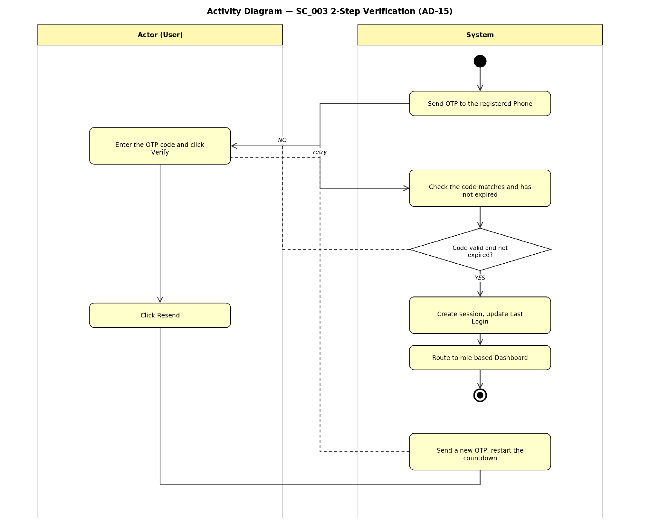
Figure — Activity Diagram: SC_003 2-Step Verification (AD-15)
d) Error Messages
Case | Message
Missing OTP code | OTP code is required
Incorrect OTP | The verification code is incorrect. Please try again.
OTP expired | This code has expired. Please request a new one.
The remaining screens in the Auth & Shared group that still need to duplicate block 3.1.2 (SC_001 — Login is already fully specified in section 3.1.1):
- SC_014 — SH-US-01 — Dashboard — Nurse
- SC_015 — SH-US-01 — Dashboard — DON
- SC_016 — SH-US-01 — Dashboard — CNA

3.2. MODULE AD — System Administration
System configuration and account administration group. Change the Screen ID to follow the AD-[Sequence] convention.
Full list of screens in this group (duplicate the 4-block structure from section 3.1.2 for each row):
- SC_008 — AD-06 — LOC rate table
- SC_009 — AD-07 — Staffing ratio
- SC_010 — AD-08 — Incident severity levels
- SC_011 — AD-09 — SLA configuration
- SC_012 — AD-10 — Demo data seeder
- SC_013 — AD-16 — Equipment & supply inventory

3.2.1. User List (Screen ID: AD-01)
a) Function Information
Function Name | User List
High-Level Requirement | Displays all Account records for administration; supports search and bulk deactivation (updates Account.Status).
User | System Admin.
Description | Lists user accounts with Email, Phone, 2FA status, Last Login, and Status; supports search by Email/Phone and bulk deactivation.
Trigger | System Admin navigates to User List (AD-01).
Precondition | Actor is authenticated as System Admin.
Post-Condition | N/A for search/view; “Deactivate Selected” updates Account.Status for the selected rows.
b) Screen Content
Field | Type | Data | Required | Description
Search (Email/Phone) | TextField – String(50) | Default blank | No | Filters the grid to accounts whose Email or Phone contains the entered value.
Search | Button |  |  | Runs the search.
Reset | Button |  |  | Clears the search criteria back to default.
Grid: Email / Phone / 2FA Status / Last Login / Status | Grid, with row-selection checkbox | All matching accounts, 10/page | N/A | 2FA Status shows a distinct “Not-set” badge for accounts that have not completed activation.
Deactivate Selected | Button |  |  | Enabled when ≥ 1 row is selected; sets Status = Deactivated for all selected accounts.
c) Actions
Actor | Actor | System | System
Main Flow: Search & view users
1 | Actor optionally enters a search string (Email/Phone) and clicks Search.
 |  | 2 | Filters accounts whose Email or Phone contains the entered value and displays results in the grid, 10 records per page.
Alternate Flow: Deactivate selected accounts
1 | Actor selects one or more rows and clicks “Deactivate Selected.”
 |  | 2 | Shows a confirmation popup with focus defaulting to Cancel.
 |  | 2.1 | If actor confirms → sets Status = Deactivated for all selected accounts; they can no longer log in; the grid refreshes.
Exception Flow: Direct link access by non-Admin
1 | A non-System-Admin actor attempts to open AD-01 via direct link.
 |  | 2 | Denies access.
d) Error Messages
Case | Message
No records match the search criteria | No records found
Non-Admin direct access | You do not have permission to access this page

3.2.2. Create / Edit User (Screen ID: AD-02)
a) Function Information
Function Name | Create / Edit User
High-Level Requirement | Creates a new Account (Status = Invited, triggers an activation invite) or edits the Role/Status of an existing Account.
User | System Admin.
Description | Provisions new staff accounts with a required unique Email, optional Phone, and a Role; or edits an existing account's Role/Status.
Trigger | System Admin clicks “Create” on User List (AD-01), or “Edit” on an existing row.
Precondition | Actor is authenticated as System Admin.
Post-Condition | On create: new Account with Status = Invited and an activation invite sent. On edit: Role/Status changes take effect immediately.
b) Screen Content
Field | Type | Data | Required | Description
Email | TextField – String(50) | Default blank | Yes | Must be unique across all accounts; validated on Save.
Phone | TextField – String(15) | Default blank | No | Optional at creation; required later during the new user's own Account Activation.
Role | Combo-box, sorted alphabetically, no blank item | N/A | Yes | Assigns the account's role.
Status | Combo-box (edit mode only) | Active / Suspended / Deactivated | Yes (edit mode) | Changes take effect immediately on Save.
Save | Button |  |  | Persists the account (create or edit).
Cancel | Button |  |  | Closes without saving.
c) Actions
Actor | Actor | System | System
Main Flow: Create new user
1 | Actor enters Email, Role, and optionally Phone, then clicks Save.
 |  | 2 | Validates that Email is unique.
 |  | 2.1 | If unique → creates the Account with Status = Invited, sends an activation invite, closes the popup, and refreshes User List.
 |  | 2.2 | If Email already exists → blocks creation with a uniqueness validation error.
Alternate Flow: Edit existing user
1 | Actor opens an existing user in edit mode, changes Role and/or Status, and clicks Save.
 |  | 2 | Applies the change immediately: if Status is set to Suspended/Deactivated, blocks the user's next login attempt; if Role changed, the new access applies at the user's next authentication.
d) Error Messages
Case | Message
Missing data in a required field | {Field name} is required
Email already registered to another account | This email is already registered to another account

3.2.3. Role & Permission Matrix (Screen ID: AD-03)
a) Function Information
Function Name | Role & Permission Matrix
High-Level Requirement | Read-only reference of Role definitions and the Screen × Role permission matrix; does not update any entity.
User | System Admin.
Description | Displays 7 role cards with plain-language descriptions and a permission matrix (Full / View / —) with field-level nuance notes and footnotes for special-access roles.
Trigger | System Admin navigates to AD-03.
Precondition | Actor is authenticated as System Admin.
Post-Condition | N/A — read-only reference screen.
b) Screen Content
Field | Type | Data | Required | Description
Role Directory | Card list, read-only | 7 role cards | N/A | Each card shows Role name, an Internal / External IDT tag, and a plain-language description of that role's responsibilities.
Permission Matrix | Grid, read-only | Rows = screens, columns = roles | N/A | Each cell shows Full, View, or —; a legend is shown above the table; a nuance note is shown beneath a cell where a field-level nuance applies.
Footnote | Label, static |  | N/A | Confirms Physician/Dietary rows have Full (e-sign) access only on M2-US-10 IDT Acknowledgment, and no other screen.
c) Actions
Actor | Actor | System | System
Main Flow: View Role & Permission Matrix
1 | Actor opens AD-03.
 |  | 2 | Loads the 7 role cards (name, Internal/External IDT tag, description) and renders the Permission Matrix with the legend above it.
Exception Flow: Direct link access by non-Admin
1 | A non-System-Admin actor attempts to open AD-03 via direct link.
 |  | 2 | Denies access.
d) Error Messages
Case | Message
Non-Admin direct access | You do not have permission to access this page

3.2.4. Facility Settings (Screen ID: AD-05)
a) Function Information
Function Name | Facility Settings
High-Level Requirement | Configures Facility general info, Room/Bed inventory, Room Rate, and Clinical Capability records read by downstream modules.
User | System Admin.
Description | 4-tab screen: General Info, Rooms & Wings, Room Rates, and Clinical Capability; each tab edits a distinct facility configuration area.
Trigger | System Admin navigates to AD-05.
Precondition | Actor is authenticated as System Admin.
Post-Condition | Saved values are read by downstream screens: Pre-Admission Screening reads Clinical Capability; the Care Plan Cost Panel reads Room Rate.
b) Screen Content
Field | Type | Data | Required | Description
[General Info] Facility name | TextField – String(100) | Default blank | Yes | Facility display name.
[General Info] Timezone | Combo-box, sorted alphabetically, no blank item | N/A | Yes | Facility's operating timezone.
[General Info] Target state | Combo-box, sorted alphabetically, no blank item | N/A | Yes | The state used for State Holiday and licensing context.
[General Info] License # | TextField – String(50) | Default blank | Yes | Facility license number.
[General Info] Facility ID | TextField, read-only | System-generated | N/A | Cannot be edited.
[General Info] Save Changes | Button |  |  | Persists General Info tab values.
[Rooms & Wings] Grid: Wing / Room / Bed / Room Type / Status / Occupancy / Occupant-Note | Grid, read-heavy | 1 row per bed (a semi-private room shows 2 rows) | N/A | Occupancy shows “1/2 occupied” or “2/2 occupied” for semi-private rooms, or “—” for private/out-of-service rooms.
[Rooms & Wings] Add Room | Button |  |  | Adds a new room/bed row.
[Room Rates] Rate | TextField – Numeric | Default blank | Yes | Rate value per Room Type.
[Room Rates] Effective Date | Date Picker (DD/MM/YYYY) | Default blank | Yes | Date the rate takes effect.
[Room Rates] Save Changes | Button |  |  | Persists the updated rate; read by the Care Plan Cost Panel for future estimated-cost figures.
[Clinical Capability] Capability item toggle | Checkbox list, sorted alphabetically | Supported / Not Supported per item | N/A | Read by Pre-Admission Screening when checking a resident's needs.
[Clinical Capability] Footnote | Label, static |  | N/A | When “Bariatric care needs” = Not Supported, states the facility-wide bed weight limit (300 lb) as the reason.
c) Actions
Actor | Actor | System | System
Main Flow: Edit General Info
1 | Actor edits Facility name / Timezone / Target state / License # on the “General Info” tab and clicks “Save Changes.”
 |  | 2 | Validates required fields and persists the values; Facility ID remains read-only.
Alternate Flow: View Rooms & Wings
1 | Actor opens the “Rooms & Wings” tab.
 |  | 2 | Renders one row per bed (a semi-private room shows 2 rows) and computes the Occupancy column.
Alternate Flow: Update a Room Rate
1 | Actor updates a rate value with an Effective Date on the “Room Rates” tab and clicks “Save Changes.”
 |  | 2 | Persists the rate; the Care Plan Cost Panel reads this value for future estimated-cost figures.
Alternate Flow: Update Clinical Capability
1 | Actor toggles a capability item to Not Supported on the “Clinical Capability” tab.
 |  | 2 | Persists the change; Pre-Admission Screening reflects the updated status when checking that need for a new resident.
Exception Flow: Direct link access by non-Admin
1 | A non-System-Admin actor attempts to open AD-05 via direct link.
 |  | 2 | Denies access.
d) Error Messages
Case | Message
Missing data in a required field (General Info) | {Field name} is required
Non-Admin direct access | You do not have permission to access this page

3.2.5. Facility Settings — tab “Holidays” (Screen ID: AD-05)
a) Function Information
Function Name | Facility Settings — Holidays Tab
High-Level Requirement | Manages State Holiday records (Active/Inactive) for the facility's active state; does not affect compliance calculations.
User | System Admin.
Description | Second tab of AD-05 Facility Settings. Lists State Holidays for the facility's active state with a Status toggle per row, plus a read-only Federal Holidays reference section.
Trigger | System Admin clicks the “Holidays” tab on AD-05 Facility Settings.
Precondition | Actor is authenticated as System Admin; the facility's active state is set (e.g., California).
Post-Condition | Toggled Status is saved immediately with an audit stamp; historical shift/task/incident records referencing a since-deactivated holiday remain unchanged (HOL-BR-04).
b) Screen Content
Field | Type | Data | Required | Description
State Holidays Configuration header | Label, static | Shows active state (e.g. California) | N/A | Section header above the State Holidays grid.
Grid: Name / Date / Repeat Annually / Status / Edit | Grid | 1 row per State Holiday | N/A | Status is an On/Off toggle; Edit is a link opening SC_047; no delete control exists (HOL-BR-03).
+ Add State Holiday | Button |  |  | Opens the Add/Edit State Holiday popup (SC_047) in Add mode.
Federal Holidays (System-Defined, read-only) | Grid, read-only | 11 fixed dates | N/A | Reference only — no Add/Edit/toggle controls (HOL-BR-01).
c) Actions
Actor | Actor | System | System
Main Flow: View & toggle State Holidays
1 | Actor clicks the “Holidays” tab on AD-05.
 |  | 2 | Renders the “State Holidays Configuration” header with the active state, the State Holidays grid, and the read-only Federal Holidays section below.
Alternate Flow: Deactivate a State Holiday
1 | Actor switches a Status toggle from On to Off.
 |  | 2 | Sets that holiday to Inactive immediately (no confirmation dialog) and records an audit stamp (name + timestamp).
Alternate Flow: Reactivate a State Holiday
1 | Actor switches a Status toggle from Off to On.
 |  | 2 | Sets Status to Active immediately and logs a separate audit entry, distinct from the original creation stamp.
Alternate Flow: Open Add/Edit popup
1 | Actor clicks “+ Add State Holiday” or “Edit” on a row.
 |  | 2 | Opens the Add/Edit State Holiday popup (SC_047).
Exception Flow: Direct link access by non-Admin
1 | A non-System-Admin actor attempts to open AD-05 via direct link.
 |  | 2 | Denies access, consistent with the rest of the Admin console.
d) Error Messages
Case | Message
Non-Admin direct access | You do not have permission to access this page

3.2.6. Add/Edit State Holiday Popup (Screen ID: AD-05)
a) Function Information
Function Name | Add/Edit State Holiday Popup
High-Level Requirement | Creates or updates a State Holiday record shown on the Holidays tab (SC_046).
User | System Admin.
Description | Single popup shared for Add and Edit actions, opened from the Holidays tab (SC_046).
Trigger | System Admin clicks “+ Add State Holiday” or “Edit” on a State Holiday row on SC_046.
Precondition | Actor is on the Holidays tab (SC_046).
Post-Condition | On Save: the State Holiday list on SC_046 reflects the new/updated record. On Cancel: no changes are applied.
b) Screen Content
Field | Type | Data | Required | Description
Holiday Name | TextField – String(100) | Default blank | Yes | Name of the State Holiday.
Date Type | Combo-box (Fixed Date / Floating Rule), no blank item | N/A | Yes | Determines whether Month+Day or a Floating Rule text is used.
Month + Day | Date-related field, shown when Date Type = Fixed Date | Default blank | Yes (when shown) | Fixed calendar date of the holiday.
Floating Rule text | TextField – String(100), shown when Date Type = Floating Rule | Default blank | Yes (when shown) | Free-text rule, e.g. “4th Friday of September”; stored as entered since the actual date shifts every year.
Repeats every year | Checkbox | Default unchecked | No | Marks the holiday as recurring annually.
Add Holiday / Save Changes | Button |  |  | Label is “Add Holiday” in Add mode, “Save Changes” in Edit mode.
Cancel | Button |  |  | Closes the popup without saving.
Audit stamp (Edit mode only) | Label, static |  | N/A | Shows who last updated the record and when.
c) Actions
Actor | Actor | System | System
Main Flow: Add a new State Holiday
1 | Actor clicks “+ Add State Holiday” on SC_046.
 |  | 2 | Opens the popup titled “Add State Holiday” with an empty form.
3 | Actor fills in the fields and clicks “Add Holiday.”
 |  | 4 | Validates that Holiday Name is not blank and, for Fixed Date, that the Month/Day does not duplicate an existing Active State Holiday (HOL-BR-02).
 |  | 4.1 | If valid → saves the new State Holiday, closes the popup, and refreshes the Holidays grid.
 |  | 4.2 | If Holiday Name is blank → blocks with a required-field error.
 |  | 4.3 | If the Fixed Date duplicates an existing Active holiday → blocks with the HOL-BR-02 error.
Alternate Flow: Edit an existing State Holiday
1 | Actor clicks “Edit” on a State Holiday row on SC_046.
 |  | 2 | Opens the popup titled “Edit State Holiday,” pre-filled with the current values, plus an audit stamp of the last update.
3 | Actor changes Month/Day (or other fields) and clicks “Save Changes.”
 |  | 4 | Saves the change; only future occurrences use the new date — past/historical records remain unchanged (HOL-BR-04).
Alternate Flow: Floating Rule entry
1 | Actor selects Date Type = Floating Rule and enters rule text (e.g. “4th Friday of September”).
 |  | 2 | Stores the rule text as entered rather than a fixed Month/Day.
Alternate Flow: Cancel
1 | Actor clicks Cancel or the dismiss icon.
 |  | 2 | Closes the popup; no changes are applied.
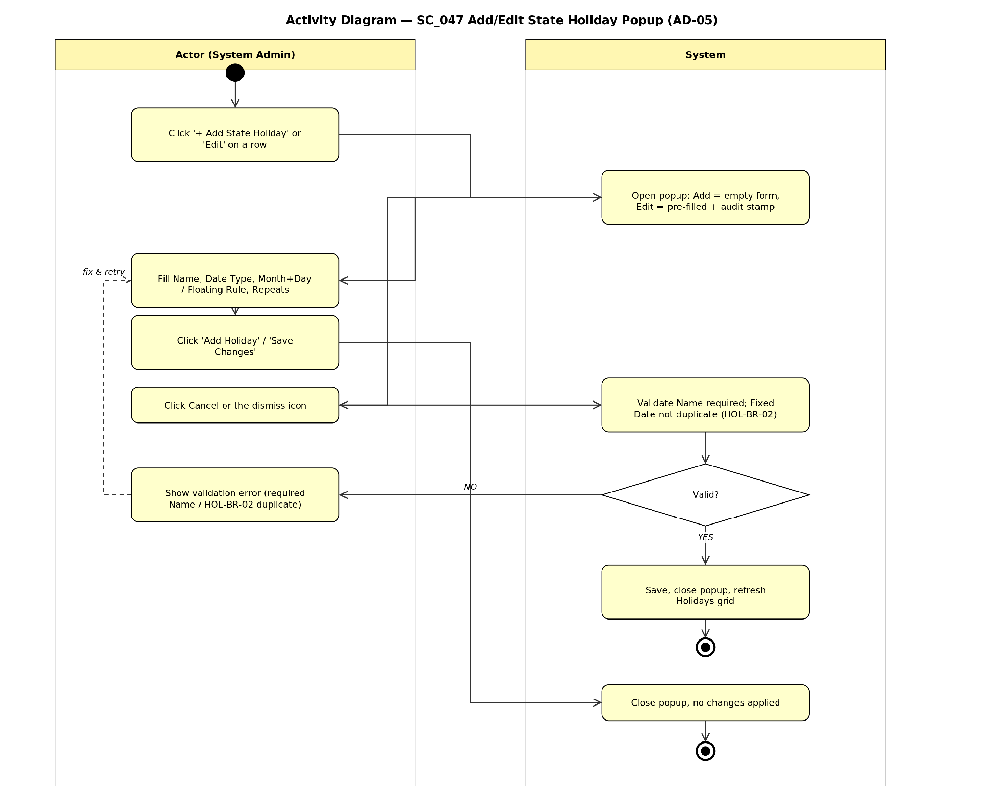
Figure — Activity Diagram: SC_047 Add/Edit State Holiday Popup (AD-05)
d) Error Messages
Case | Message
Missing Holiday Name | Holiday Name is required
Fixed Date duplicates an existing Active State Holiday | This date is already used by another active State Holiday (HOL-BR-02)

3.3. MODULE M1 — Intake & EHR
Intake, clinical assessment, and LOC classification group. Change the Screen ID to follow the M1-US-[Sequence] convention.
Full list of screens in this group (duplicate the 4-block structure from section 3.1.2 for each row):
- SC_017 — M1-US-01 — Resident list
- SC_018 — M1-US-02 — Resident profile detail
- SC_019 — M1-US-03 — Create/edit resident
- SC_020 — M1-US-04 — Pre-admission screening
- SC_021 — M1-US-05 — Admission form
- SC_022 — M1-US-06 — Initial assessment
- SC_023 — M1-US-07 — Assessment history
- SC_024 — M1-US-08 — LOC classification
- SC_025 — M1-US-09 — LOC history

3.4. MODULE M2 — Care Planning
Care plan creation/approval, daily care tasks, and reassessment group. Change the Screen ID to follow the M2-US-[Sequence] convention.
Full list of screens in this group (duplicate the 4-block structure from section 3.1.2 for each row):
- SC_026 — M2-US-01 — Care plan list
- SC_027 — M2-US-02 — Care plan create
- SC_029 — M2-US-03 — Care plan detail
- SC_030 — M2-US-04 — DON review
- SC_031 — M2-US-04b — E-signature popup
- SC_032 — M2-US-05 — Daily task list
- SC_033 — M2-US-06 — Bedside vitals
- SC_034 — M2-US-07 — Reassessment
- SC_035 — M2-US-09 — Cost/billing panel
- SC_036 — M2-US-10 — IDT acknowledgment

3.4.1. LOC Gate (Screen ID: M2-US-02b)
a) Function Information
Function Name | LOC Gate
High-Level Requirement | Blocks Care Plan creation until Resident.LOC status = Confirmed; informational gate and navigation only, does not itself update any entity.
User | Nurse (RN/LPN).
Description | Explains why “Create Care Plan” is disabled for a resident whose LOC is not yet Confirmed, and links directly to LOC Classification to resolve it.
Trigger | Nurse clicks “New Care Plan” for a resident whose LOC = Suggested (not yet Confirmed).
Precondition | Resident's LOC classification status is not Confirmed.
Post-Condition | N/A until LOC is confirmed/overridden; once Confirmed, the gate no longer appears and “Create Care Plan” becomes enabled.
b) Screen Content
Field | Type | Data | Required | Description
Resident name / room | Label, static, read-only |  | N/A | Identifies the resident the gate applies to.
Explanation banner | Label, amber banner |  | N/A | States that LOC must be Confirmed before a care plan can be created.
Go to LOC Classification | Button |  |  | Navigates to LOC Classification for the same resident.
c) Actions
Actor | Actor | System | System
Main Flow: View LOC Gate
1 | Actor clicks “New Care Plan” for a resident whose LOC is not Confirmed.
 |  | 2 | Disables “Create Care Plan” with the tooltip “Confirm LOC classification first” and renders the LOC Gate screen with the resident's name/room, the amber banner, and the explanation card.
Alternate Flow: Navigate to resolve
1 | Actor clicks “Go to LOC Classification.”
 |  | 2 | Navigates to LOC Classification for the same resident.
Alternate Flow: Gate cleared
1 | Actor returns to “New Care Plan” for that resident after DON or Nurse confirms/overrides the resident's LOC.
 |  | 2 | No longer shows the gate; “Create Care Plan” is enabled.
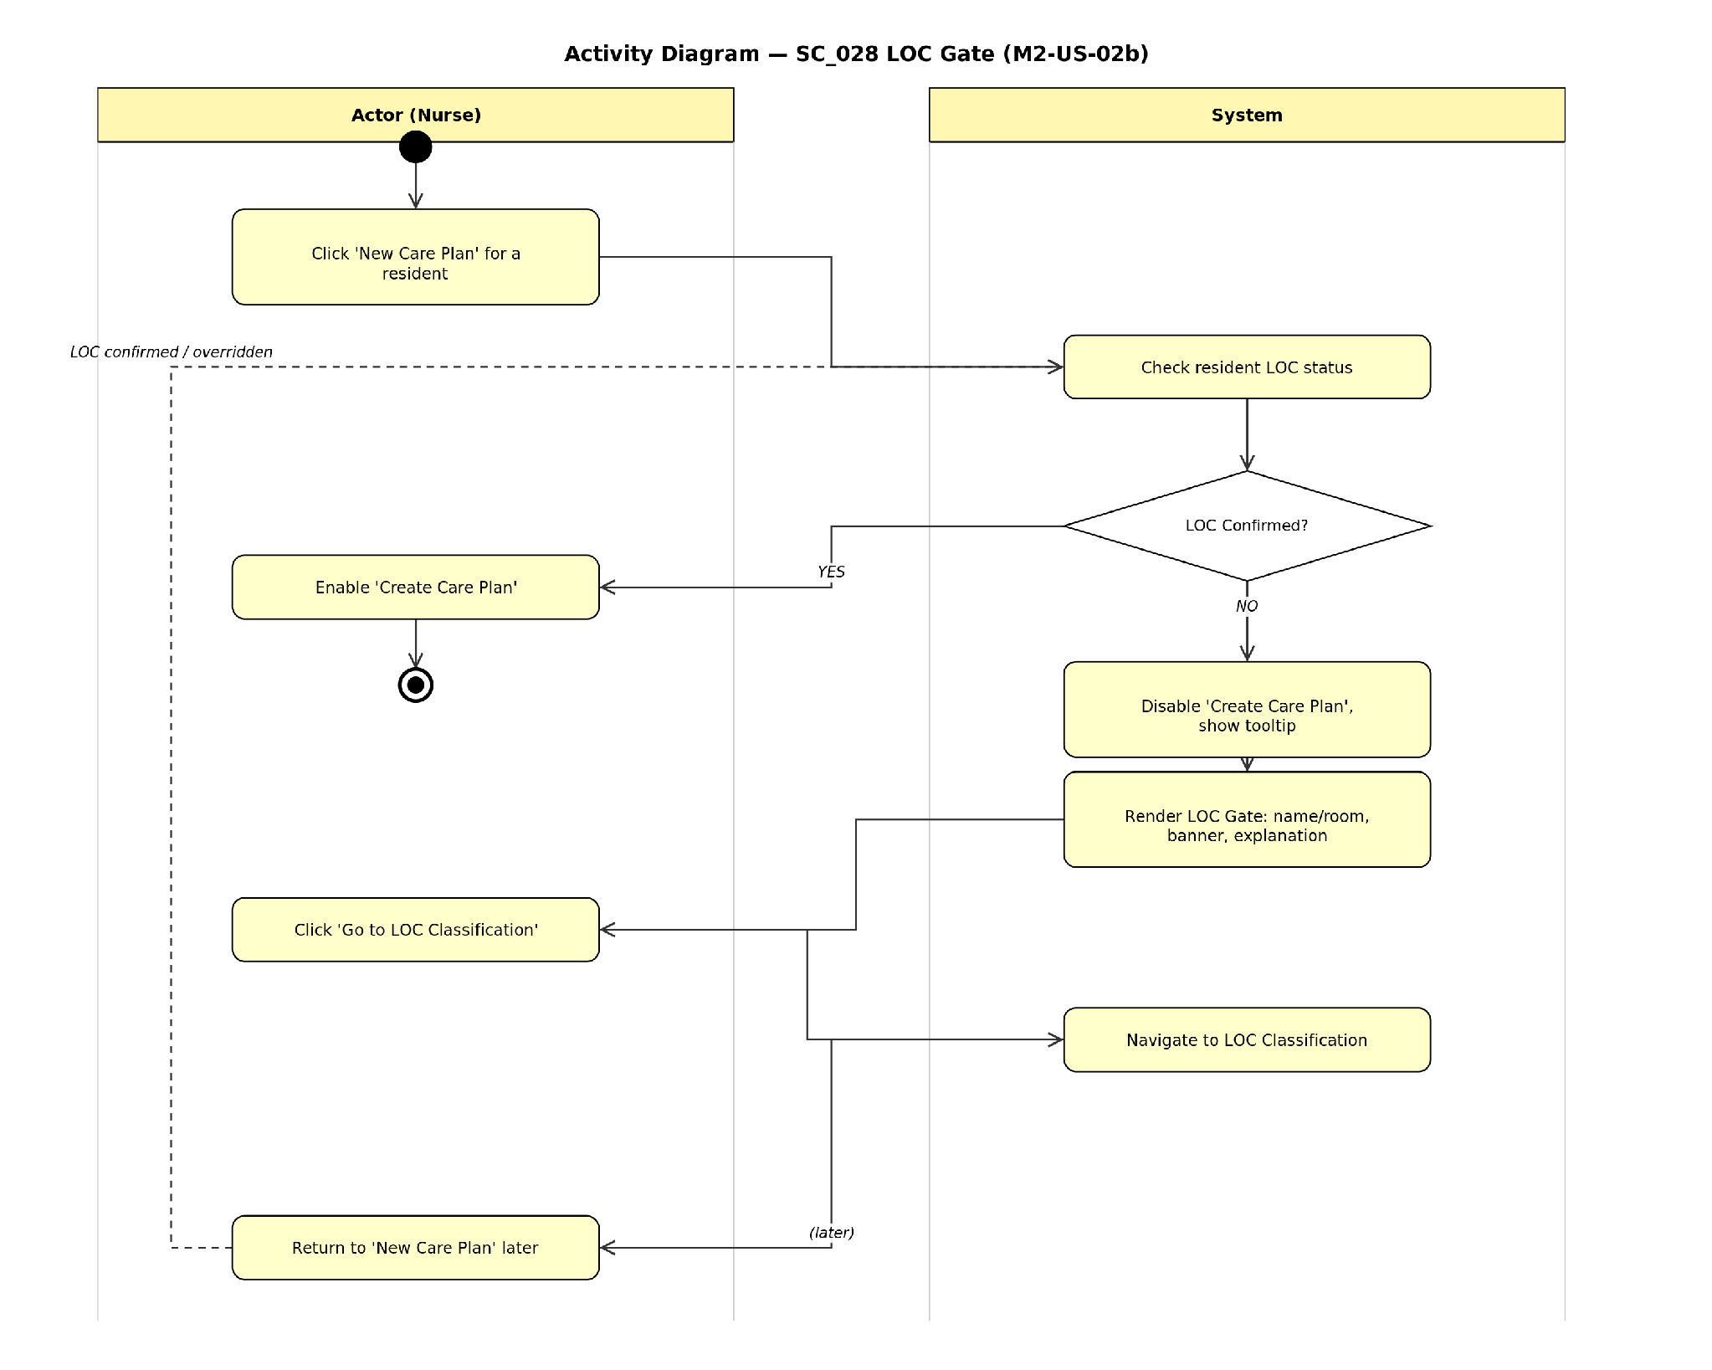
Figure — Activity Diagram: SC_028 LOC Gate (M2-US-02b)
d) Error Messages
Case | Message
LOC not yet Confirmed (attempt to create Care Plan) | Confirm LOC classification first.

3.4.2. Add Custom Care Area Popup (Screen ID: M2-US-02c)
a) Function Information
Function Name | Add Custom Care Area Popup
High-Level Requirement | Adds a custom Care Area (including “Other” category) to the Care Plan currently being created/edited.
User | Nurse (RN/LPN).
Description | Popup opened from Care Plan Create (SC_027) letting the nurse add a Care Area not covered by the system-suggested Care Areas.
Trigger | Nurse clicks “Add Custom Care Area” on Care Plan Create (SC_027).
Precondition | Actor is on Care Plan Create/Edit for a resident.
Post-Condition | On confirm: a new Care Area chip is added to the care plan with the selected Category. On cancel: no change.
b) Screen Content
Field | Type | Data | Required | Description
Care Area name | TextField – String(100) | Default blank | Yes | Name of the custom Care Area.
Category | Combo-box, no blank item | Default “Other” | Yes | Category assigned to the new Care Area.
Add | Button |  |  | Confirms and adds the Care Area.
Cancel | Button / dismiss icon |  |  | Closes the popup without adding.
c) Actions
Actor | Actor | System | System
Main Flow: Add a custom Care Area
1 | Actor clicks “Add Custom Care Area” on Care Plan Create.
 |  | 2 | Opens the popup with the Care Area name field and the Category selector defaulted to “Other.”
3 | Actor enters a Care Area name, selects a Category (or keeps the default), and clicks “Add.”
 |  | 4 | Validates that the Care Area name is not blank.
 |  | 4.1 | If valid → adds the Care Area as a new chip on the care plan with the selected Category and closes the popup.
 |  | 4.2 | If blank → blocks the action with a validation error.
Alternate Flow: Cancel without adding
1 | Actor clicks Cancel or the dismiss icon.
 |  | 2 | Closes the popup; no Care Area is added to the care plan.
d) Error Messages
Case | Message
Missing Care Area name | Care Area name is required
Care plan still has 0 Care Areas at save time (cross-screen validation, same as UC-M2-01 EX2) | At least 1 Care Area with 1 goal is required

3.5. MODULE M7 — Incident Management
Incident reporting, handling, and chart lock/unlock group. Change the Screen ID to follow the M7-US-[Sequence] convention.
Full list of screens in this group (duplicate the 4-block structure from section 3.1.2 for each row):
- SC_037 — M7-US-01 — Report incident
- SC_038 — M7-US-02 — Chart lock confirmation
- SC_039 — M7-US-03 — Incident detail
- SC_040 — M7-US-04 — Incident list
- SC_041 — M7-US-06 — Submit external report
- SC_042 — M7-US-07 — Chart unlock
- SC_043 — M7-US-03b — Incident detail (unlocked)
- SC_044 — M7-US-03 — Incident detail (Nurse/CNA view)

4. UI Design Convention
The conventions below apply to all NHMS screens (light theme, following the design tokens in the project's standard wireframes), unless section 3 states a specific exception for a given function.

4.1. Textbox
- Default value is blank unless the spec states a different default.

4.2. Grid
- Displays all records from the DB by default.
- Clicking a column header sorts the data.
- Even and odd rows use different background colors for readability.

4.3. Combo-box
- Default value is a blank item unless the spec states a different default.
- Combo-box content must be sorted alphabetically unless the spec states a different order.
- A required combo-box on a Create/Edit screen must not include a blank item.
- An optional combo-box on a Create/Edit screen must include a blank item.

4.4. Date Picker
- Display format: DD/MM/YYYY.
- Allows entering a valid date directly or selecting one from the Calendar.

4.5. Message
- An error message is shown as a red inline message directly under the corresponding field.
- A success message is shown as a green toast in the top-right corner of the screen.
- A "no records found" message is shown as a red inline message directly under the grid.
- A confirmation message for Delete/Reject/Approve/Lock/Unlock is shown as a popup, with focus defaulting to the No/Cancel button.

4.6. Search Function
- When the user types into a textbox, the system searches for records containing that value.
- When the user enters/selects a value via another control (combobox, date picker…), the system searches for an exact match.
- When searching by multiple criteria, the system returns records that satisfy all entered criteria.
- The Search screen has a Reset button that returns all search criteria to their default values.
- A blank textbox/date picker, a combobox set to '(All)', or a checkbox list with '(All)' checked means that criterion is excluded from the query.

4.7. Paging Section
- Displays 10 records per page by default.
- 4 navigation buttons: First, Previous, Next, Last (each with a matching tooltip).
- On the first page, disable the First and Previous buttons.
- On the last page, disable the Last and Next buttons.
- The Page textbox allows direct page entry; the "Of n" label shows the total number of pages.
- When the grid has no records, the Page textbox shows 1 and n = 1.

4.8. Add/Edit/Delete on a Search Screen
- After adding/editing a record on a search screen: close the popup and refresh the search results.
- After deleting a record: remove it from the displayed result list as well.

4.9. Checkbox List
- Values must be sorted alphabetically unless the spec states a different order.

4.10. Checkbox
- Default value is unchecked unless the spec states a different default.

4.11. Textarea
- Default value is blank unless the spec states a different default.

